# Using blogdown

The reference manual for blogdown is at

<https://bookdown.org/yihui/blogdown/>

The notes here are from the video “Making a website with Rstudio Part 1” by John Muschelli

<https://www.youtube.com/watch?v=-9uuyJzWzCI>

Next install blogdown in Rstudio

install.packages(“blogdown”)

Next start a new Rstudio project

The steps are

File -> New Project -> Website using blogdown

If the last item is not present, than blogdown is not installed.

Next enter a directory name. Choose an appropriate name for the website

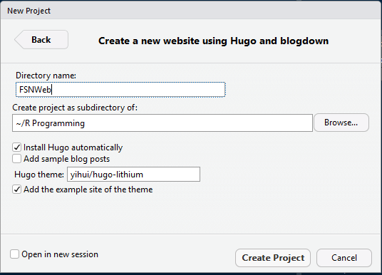

The above shows the default hugo theme

New themes can be found in <https://themes.gohugo.io/>

Going to use the academic hugo theme. Choose the academic theme and then click on the download button. This will bring you to a github webpage

Ath the github page copy the name as shown below

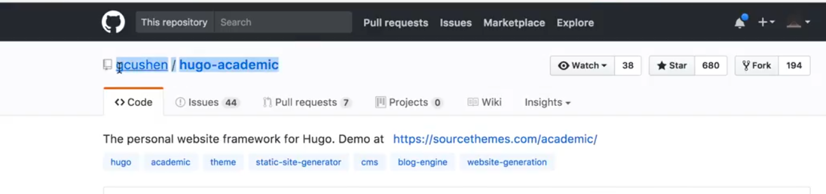

And paste it into the hugo theme area to replace the that was there

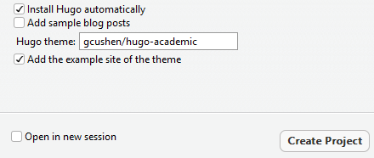

And click Create Project

This will install hugo on your machine, since Install Hugo automatically is ticked

You can also install hugo manually using

blogdown::**install_hugo**()

To update hugo, you use the command

blogdown::update_hugo()

To now build this site need to run the command

library(blogdown)

blogdown::build_site()

Once blogdown is loaded, there is a new Addins dropdown on the tool bar

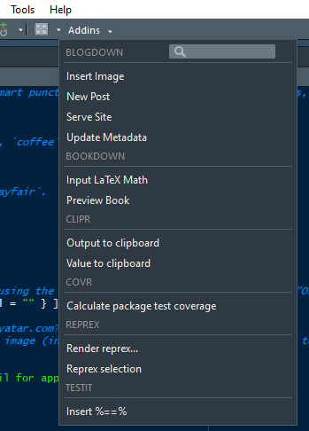

If you click on the Serve Site then it will build the site and serve it. The website can be seen in the viewer tab in Rstudio. If you click the icon ‘Show in new window’, the site will be shown in the browser

To save this to github new to initialise github in Rstudio for this project. This is done thru Tools -> Version Control -> Project Setup and choosing git for the Version Control System and initialise new Git Repository. Rstudio needs to restart if this is initialised for the first time